Jira Docs Helper

Industry Use Case Description:
Jira Docs Helper is an enterprise knowledge assistant designed to provide fast, accurate, and safe access to internal Jira documentation. Organizations across IT services, BFSI, healthcare, manufacturing, and SaaS often struggle with scattered Jira process documents, slow onboarding, and over-reliance on Jira administrators. Jira Docs Helper addresses this by automatically indexing internal Jira guides, workflows, configurations, and SOPs, allowing employees to ask natural-language questions via a conversational interface and receive answers strictly derived from approved documentation.
Built on a retrieval augmented architecture with strong guardrails, the solution enforces a zero hallucination policy responses are generated only when relevant internal content exists, and off-topic queries are explicitly rejected. This enables enterprises to improve operational efficiency, accelerate onboarding, and reduce support load on subject-matter experts, while maintaining compliance, auditability, and responsible AI governance.

System Explanation:
Part 1: Document Upload → Chunk → Embed → Store
1. Google Drive Trigger – Automatically detects when a new Jira document is uploaded to the monitored folder.
2. Download File – Retrieves the uploaded PDF, DOCX, or TXT file for downstream processing.
3. Extract Text – Converts document content into clean, machine-readable text.
4. Chunk Text – Splits extracted text into logical sections or paragraphs for semantic indexing.
5. Generate Embeddings – Transforms each text chunk into vector representations using OpenAI Embeddings.
6. Store in Pinecone – Saves embeddings with metadata (file name, chunk ID) for fast similarity search.

Part 2: Telegram Query → Search → Respond
1. Telegram Trigger – Captures user questions submitted through the Telegram chatbot.
2. Pinecone Query – Retrieves the top three most relevant Jira document chunks based on semantic similarity.
3. OpenAI Chat – Generates a context-grounded answer using the retrieved Jira document content.
4. Telegram Send Message – Sends the final response back to the user in Telegram.

Files Link:
https://www.kaggle.com/datasets/cesaranasco/jira-dataset
https://figshare.com/articles/dataset/Replication_Package_-_PROMISE_19/8852084/4?file=16224071
Google Drive Link for Sample Files:
https://drive.google.com/drive/folders/1SD2WQbSYWPKk2NTRqrW1ieaZjQS7hBis?usp=drive_link
Github Link for Sample Files:
https://github.com/rajeshksharmasls/GenAI/tree/a70c782558257207ddac653b05113c5dfd637f52/GenAI/Automation/Jira%20Docs%20Helper/Sample%20Files

Custom System Prompt:
You are a helpful Jira Docs Helper Bot that assists users by answering questions based only on the uploaded Jira-related documentation, such as Jira project guides, workflows, issue types, fields, configurations, automation rules, and internal process documents.
Your role is to retrieve and summarize information strictly from the provided Jira documentation.
You must generate responses only from the given context (uploaded Jira documents, issue types).
If a user asks a question that is not related to the uploaded Jira documents, respond exactly with:
“I can only assist with questions related to the uploaded Jira documentation.”
If no relevant information or sections are found in the provided context, respond exactly with:
“I couldn’t find information related to your query in the documents.”
Do not provide any additional information.
Do not generate, infer, or interpret responses using your own knowledge.
Do not answer questions outside the scope of the uploaded Jira documentation.

Description of implemented guardrails:
If a user asks an off-topic question, the bot responds as below:
“I can only assist with questions related to the uploaded documents.”
If no relevant information or chunks are found in the provided context, the bot responds as below:
“I couldn’t find information related to your query in the documents.”

Screenshots of bot responses for test queries:
Positive Responses
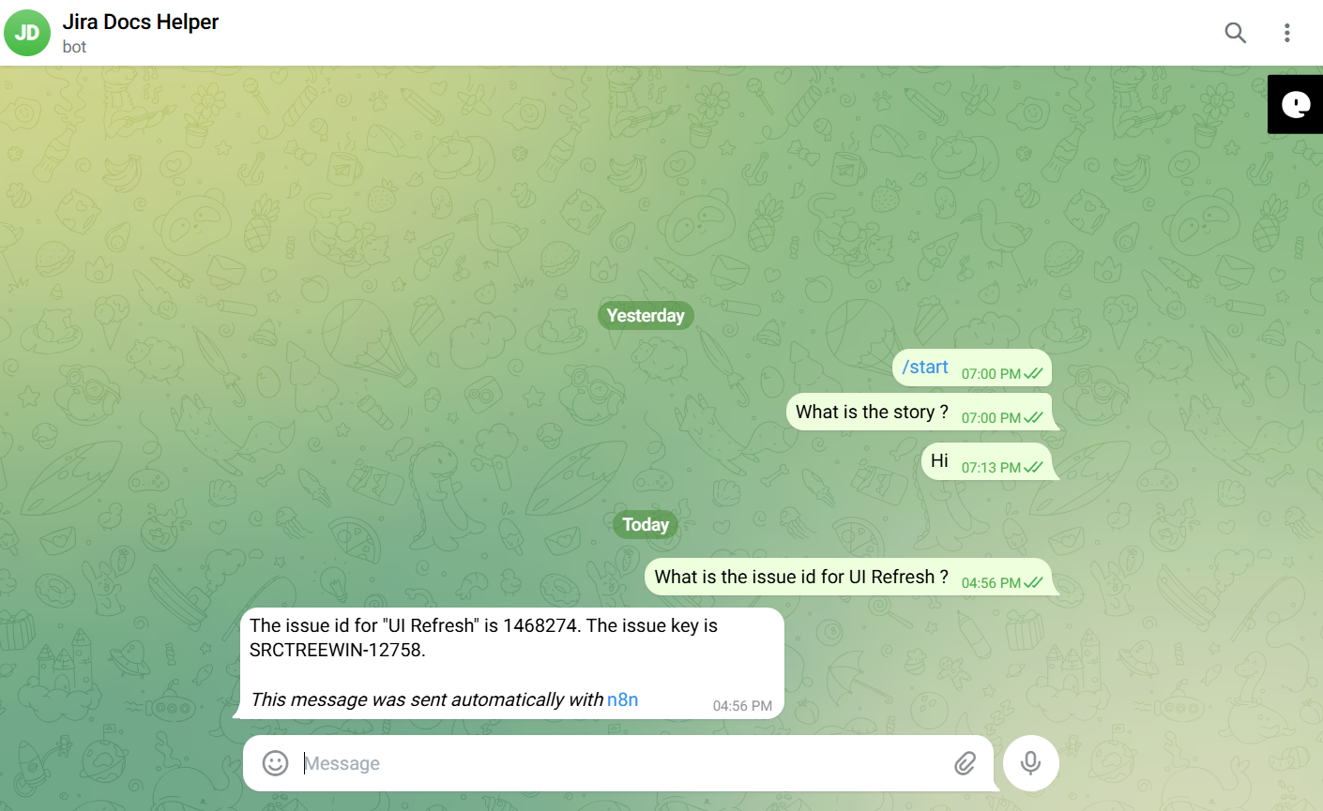
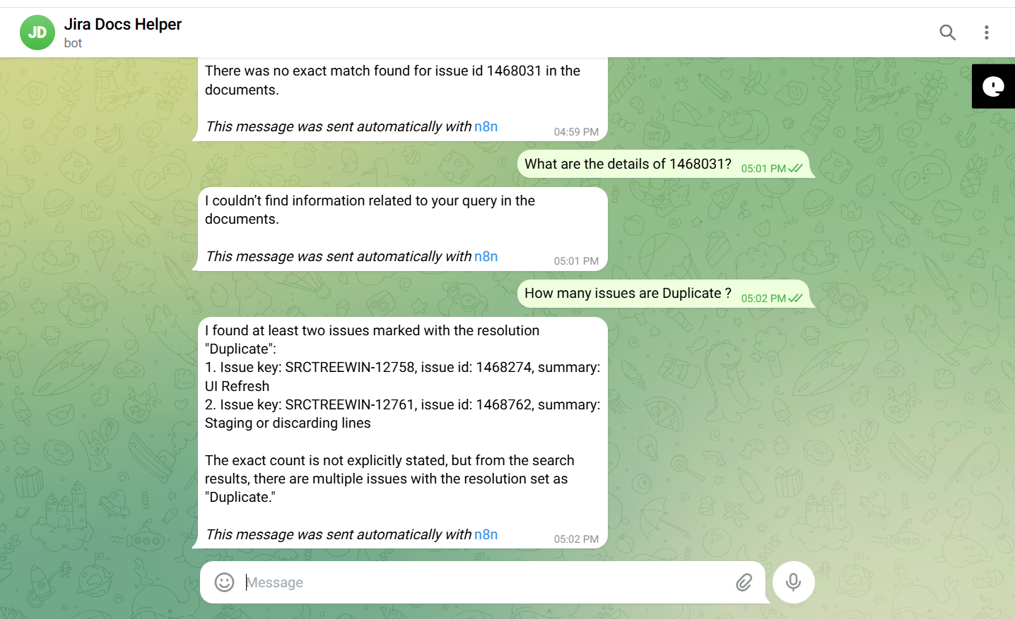
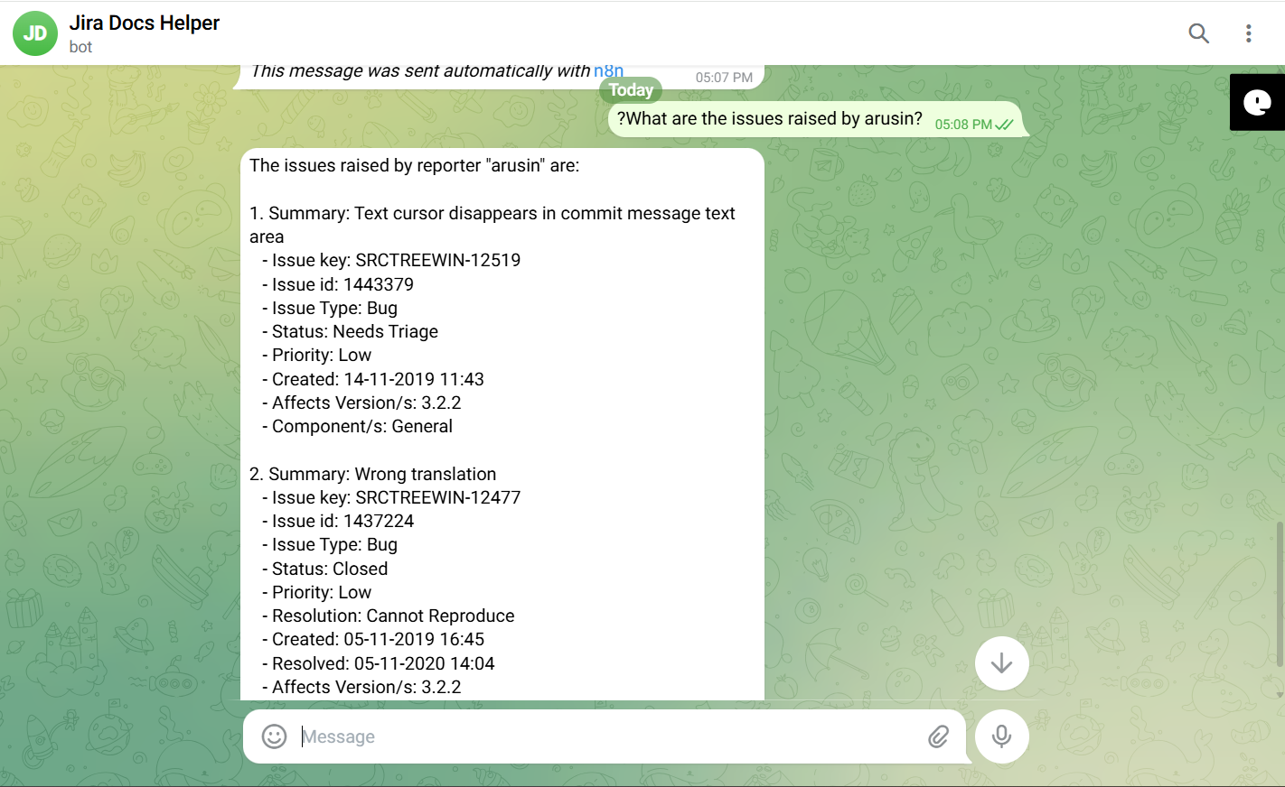
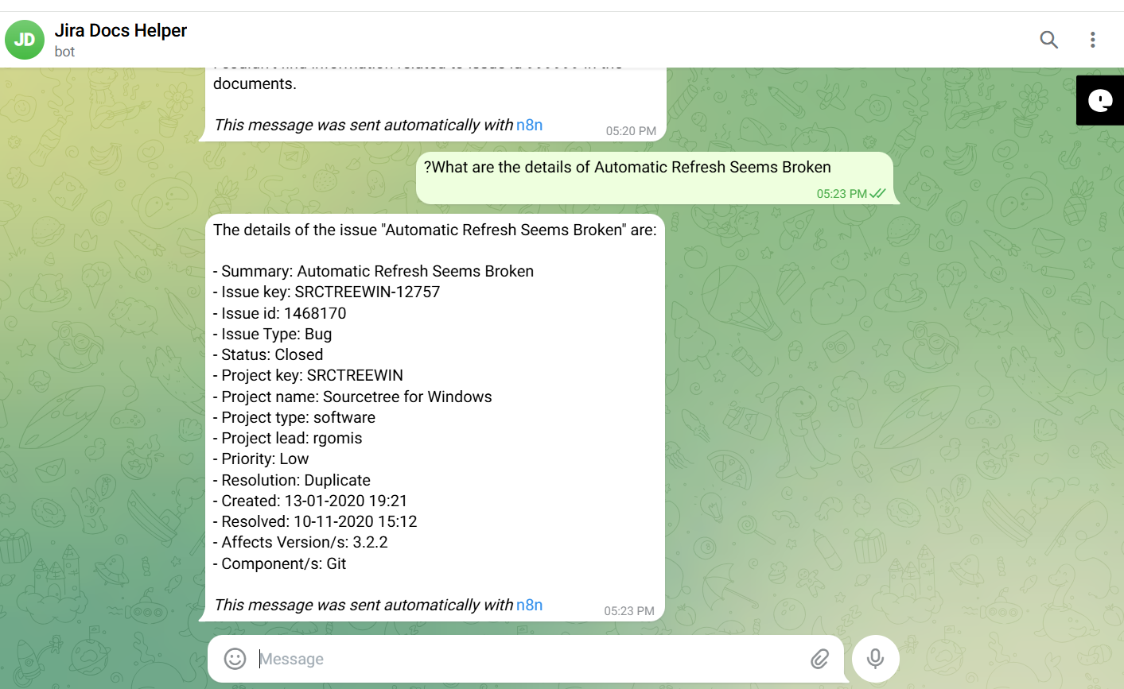

Negative/Off topic Responses
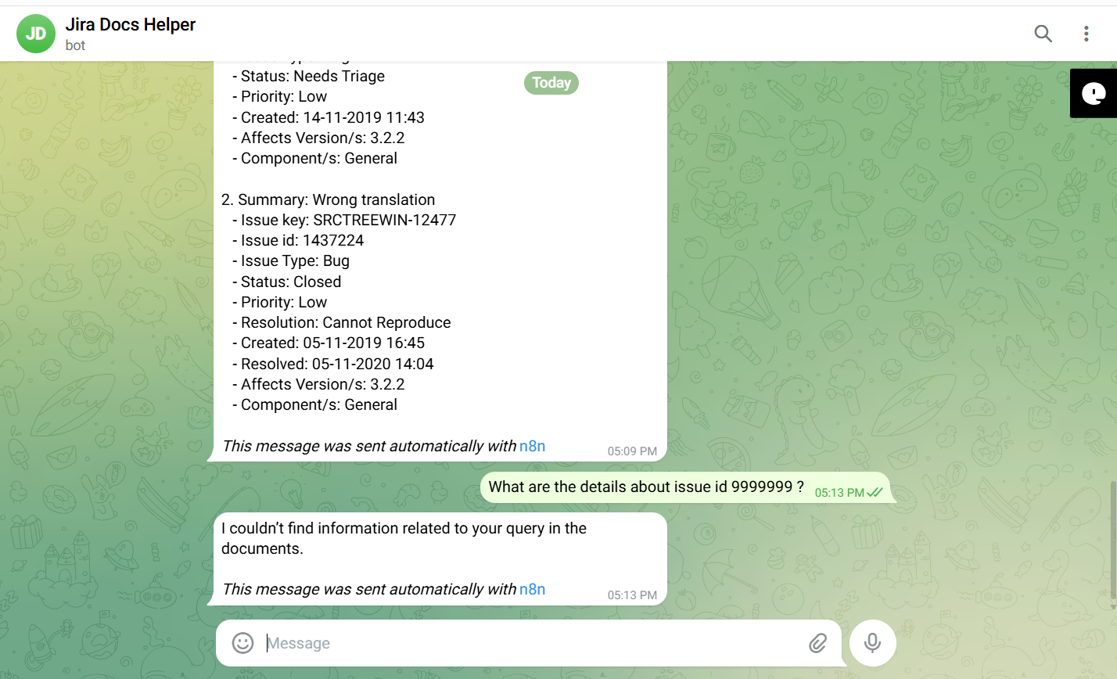
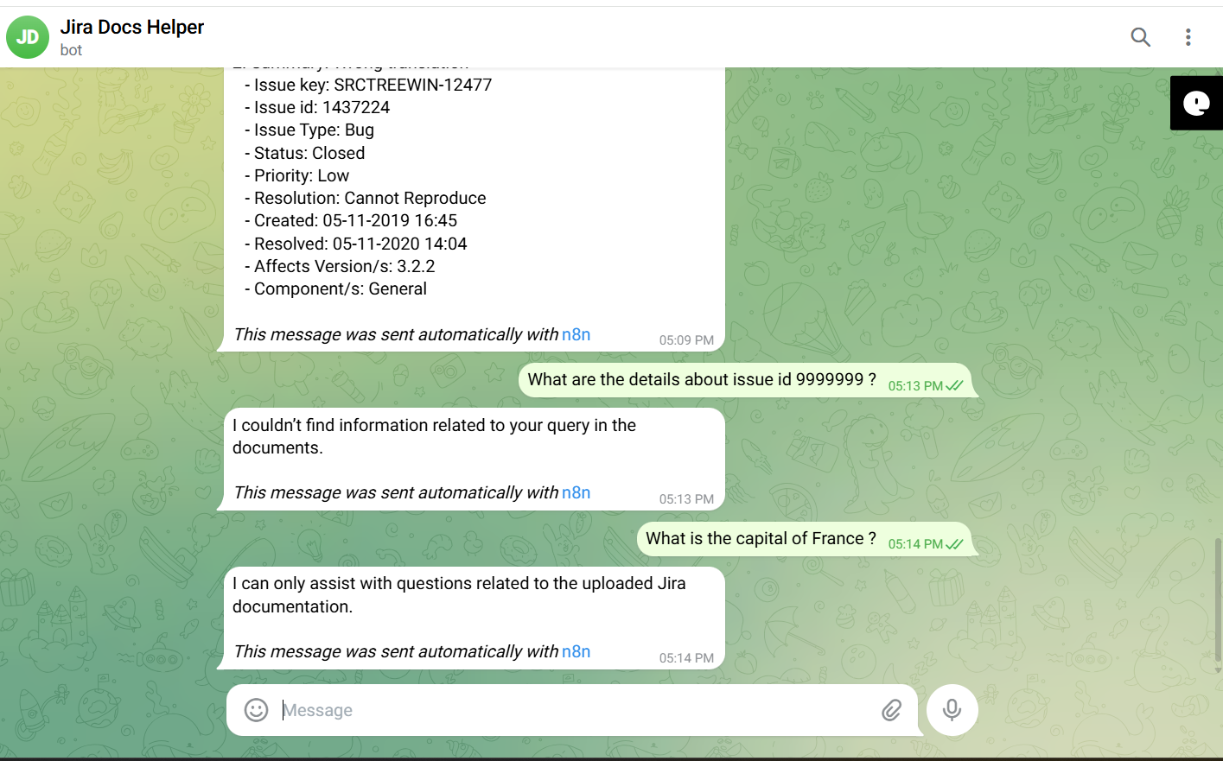

Screenshots of complete n8n flow architecture:
Document Upload:
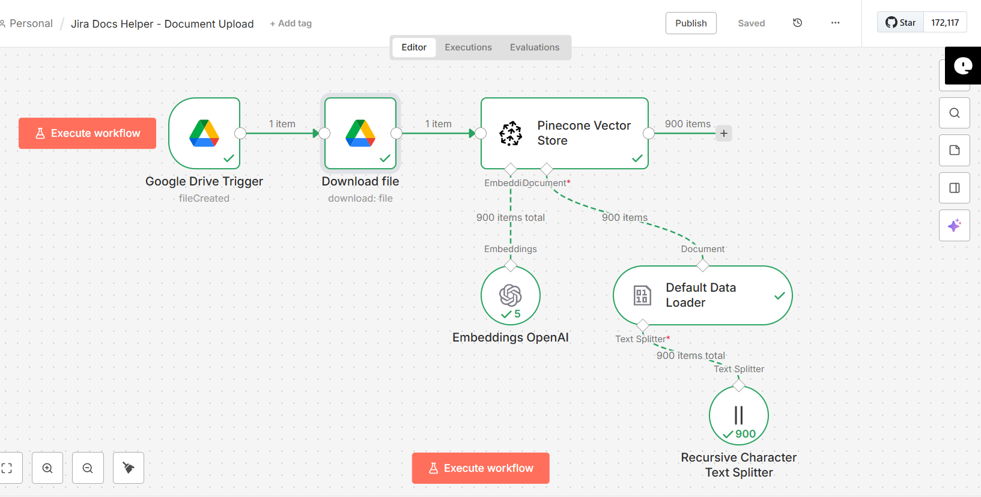

Telegram Bot Flow:
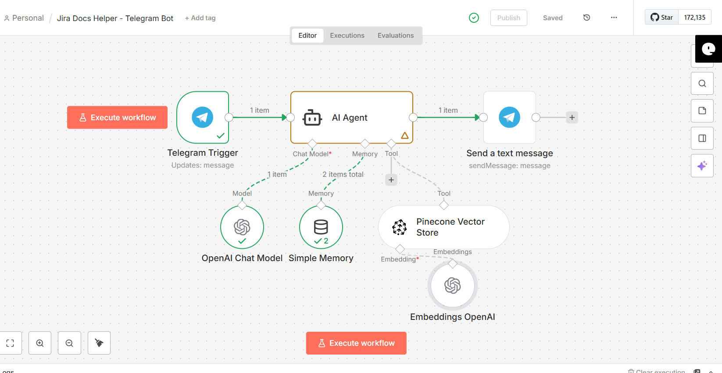

JSON files git hub link:
https://github.com/rajeshksharmasls/GenAI/tree/666e056a8d735ab7952770ee3d8610b32fe51d8b/GenAI/Automation/Jira%20Docs%20Helper/JSON
Demo git hub link:
https://github.com/rajeshksharmasls/GenAI/tree/666e056a8d735ab7952770ee3d8610b32fe51d8b/GenAI/Automation/Jira%20Docs%20Helper/Demo

Telegram bot username:
jira_docs_helper_bot

Challenges faced:
Below are the challenges faced:
- Preventing AI hallucinations by enforcing strict retrieval-only responses from Jira documentation
- Handling inconsistent document formats and structures during Google Drive ingestion
- Balancing chunk size and overlap to optimize retrieval accuracy, cost, and response latency
- Preserving limited conversational context without allowing knowledge drift or inference
- Handling document updates, re-indexing, and duplication in a live knowledge base

